THE ATTUNED SCHOOL

DAY 1: THE NEW 3 RS: RELATIONSHIP, REGULATION & RESILIENCY

CREATING EMOTIONALLY SAFE, WELL-REGULATED, NURTURING, & ATTUNED EDUCATIONAL ENVIRONMENTS

PRESENTED BY
FRANK PICONE LCSW
Conscious Trauma Attuned Resiliency Institute (CTARI)
Center for Great Expectations
fpicone@cge-nj.org

l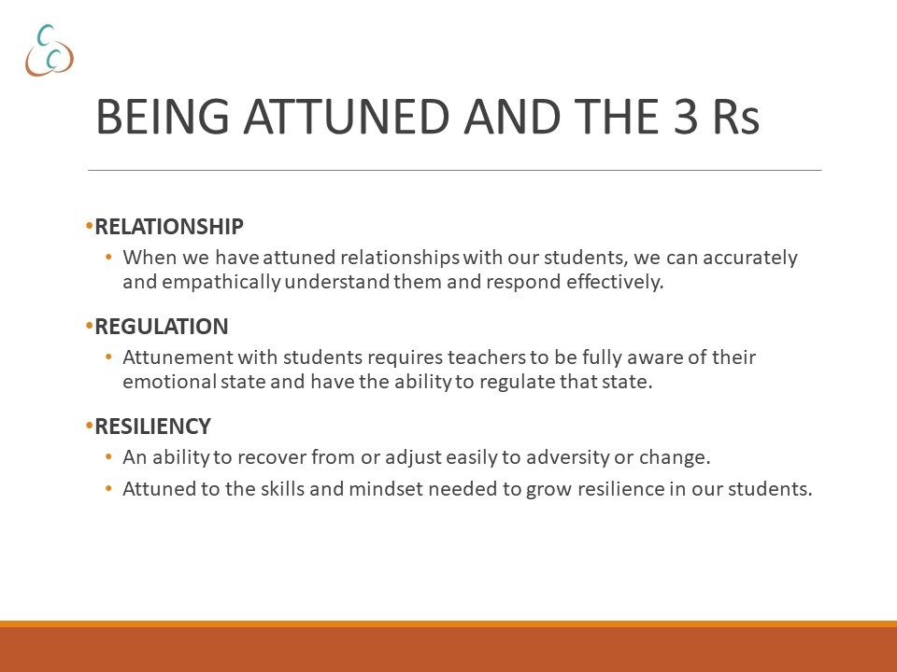
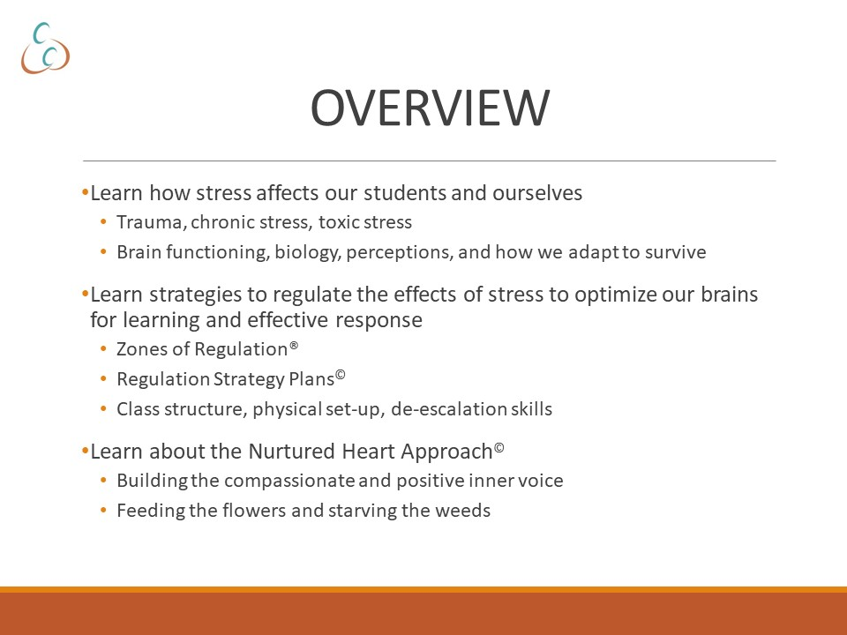
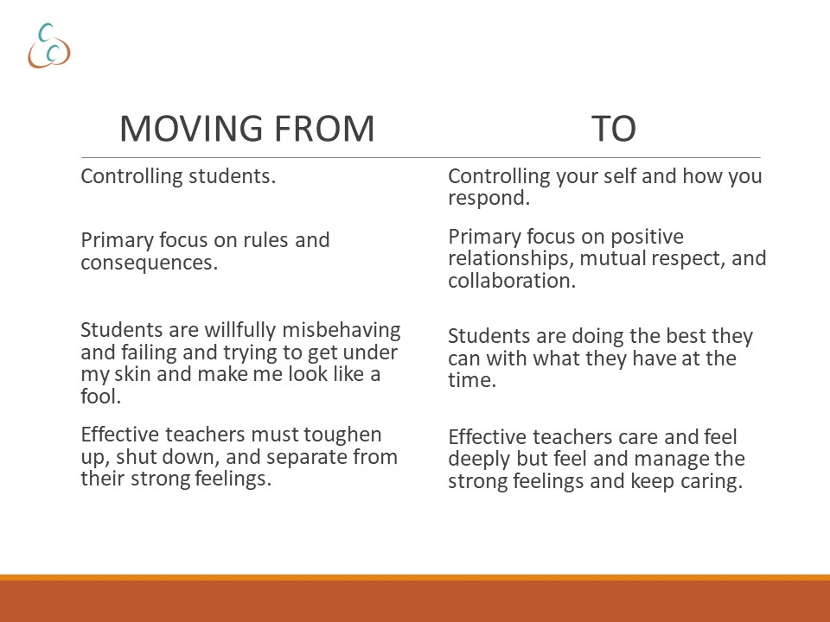
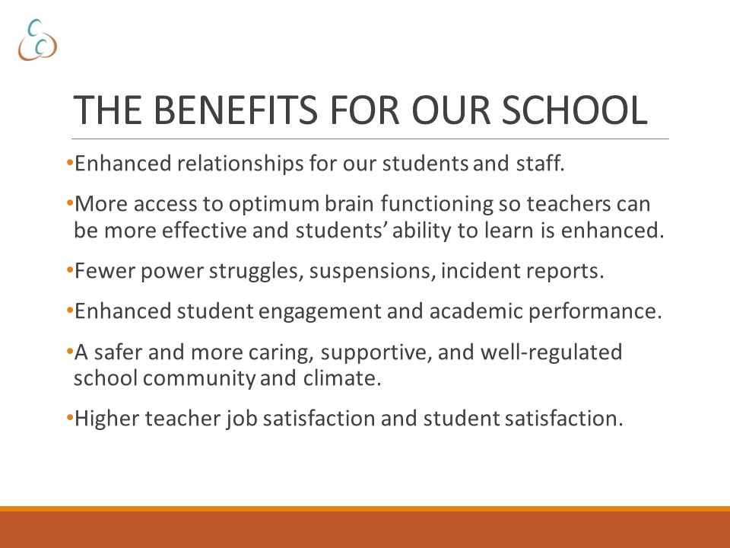

JOURNEY TO WAR

List the ways of thinking, feeling and behaving that you think are necessary for your survival in a war:

1. Ways of thinking and viewing the world:
____________________________________________________________________________________________________________________________________________________________________________________________________________________________________________________________________________________________________________

2. Identify emotions that make you vulnerable:
____________________________________________________________________________________________________________________________________________________________________________________________________________________________________________________________________________________________________________

3. Identify key behaviors for survival:
____________________________________________________________________________________________________________________________________________________________________________________________________________________________________________________________________________________________________________

TRACING BACK THE ORIGINS OF THE STUDENT’S SURVIVAL SKILLS

Draw a line to connect the survival skills with the environment they were most likely cultivated for:
`

Survival Skill Environmental Stress

Lying Lack of safe relationships

Stealing Loss of loved ones

Violence Chronic stress

Emotional shut down Sexual abuse

Distrust Very harsh punishments

Verbal abuse Basic needs not met

Gang involvement Cursed at by caretaker

Hyper-vigilance Physical abuse

Very poor hygiene Alcoholic parents

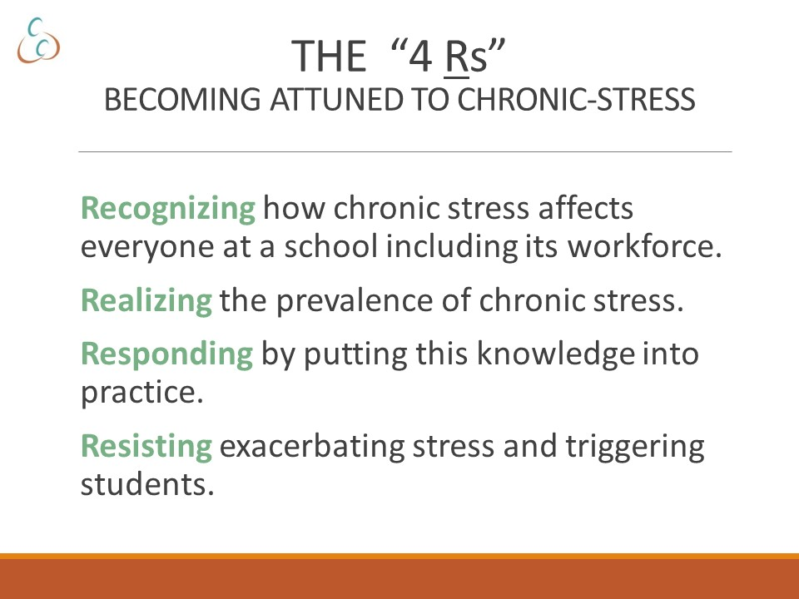
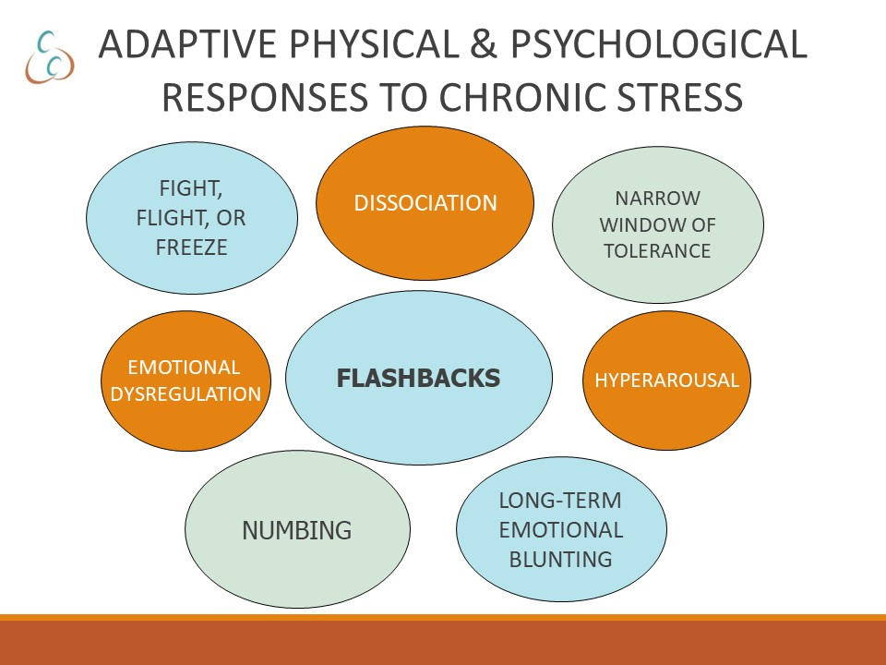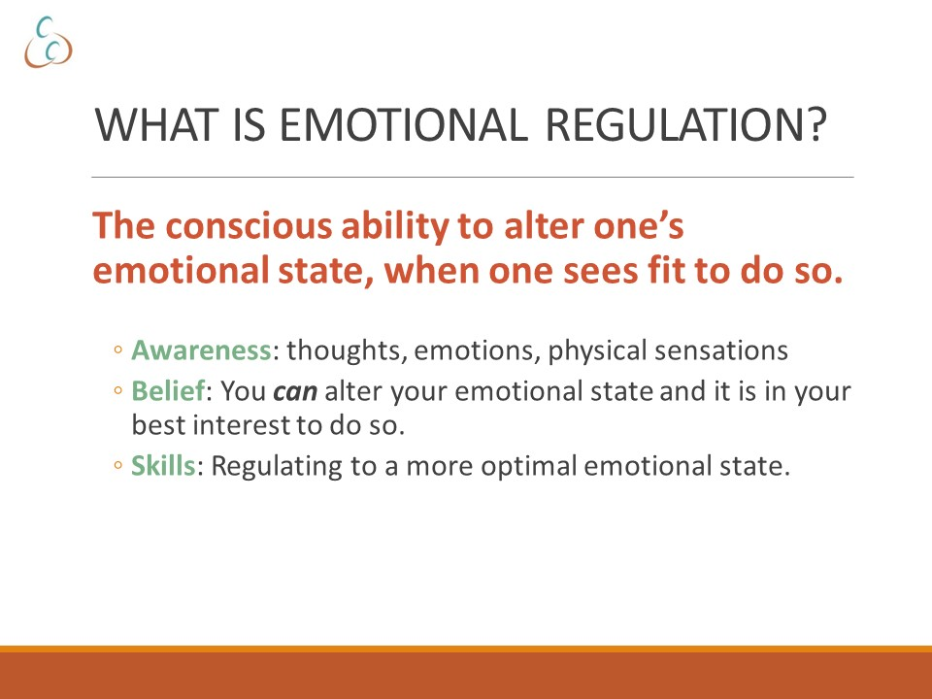

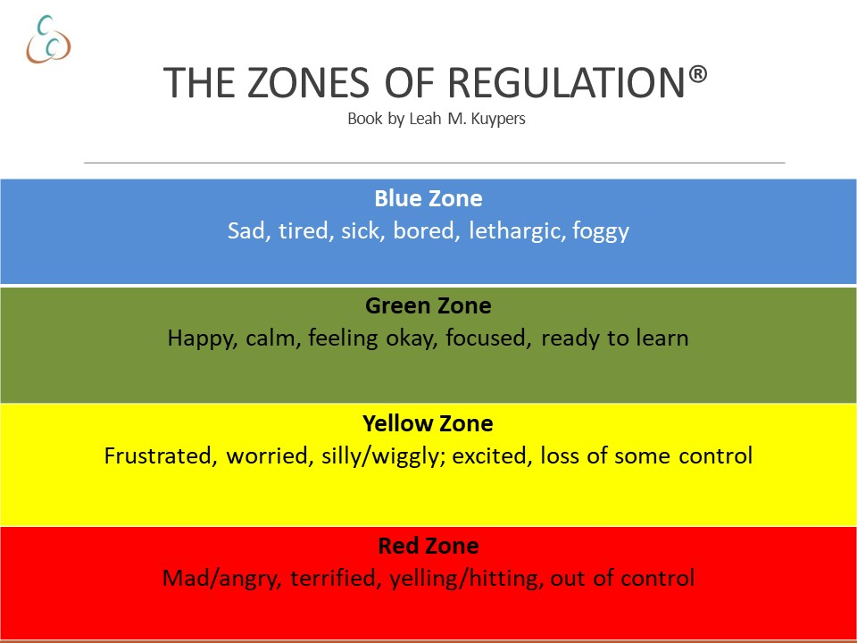
ATTUNED
BODY LANGUAGE

Paralleling: Rather than face someone frontally—or “square off” position yourself at an angle.
Proximity: Maintain a distance that is comfortable for both participants
Posture: Erect posture
Pace of Response and Pausing to Reflect
Pace of Body Movement: Controlled, not sudden
Eye Contact: Soft gaze, intermittent
Facial Expression: Loose jaw, receptive
Tone of Voice: Rhythmic, melodic
Length of sentences: Longer sentences are more soothing
ATTUNED
PERSONAL
REGULATION STRATEGY PLANS (RSPs)

Triggers

For this activity, write one or two types of events or behaviors that trigger you to become escalated or agitated.

Trigger #1: ____________________________________________

Trigger #2: ____________________________________________

Warning Signs

Write down one or more warning signs that occur in your body—or a behavior—that signal an escalated or agitated state:
1) __________________________________________________________
- __________________________________________________________
- __________________________________________________________

Strategies
List one or more helpful strategies to calm and de-escalate yourself:
- __________________________________________________________
- __________________________________________________________
- __________________________________________________________

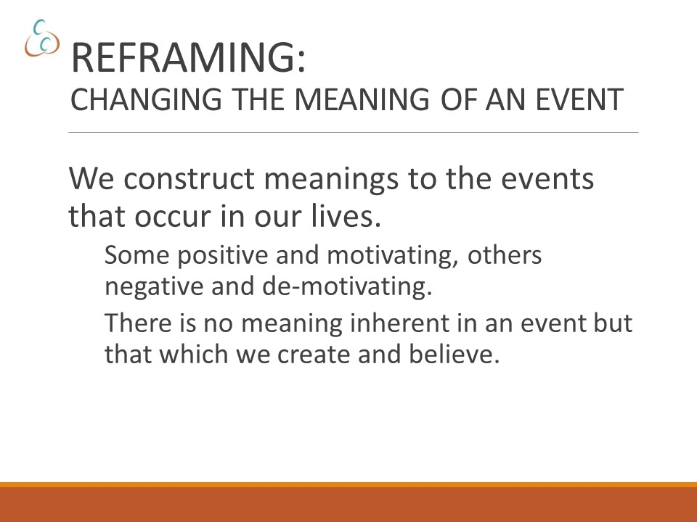

REGULATION STRATEGY PLAN (RSP)
FOR STUDENTS
Things that upset me!
1) _______________________________________________________________
2) _______________________________________________________________
3) _______________________________________________________________
How people can tell I’m upset:
1) _________________________________________________________________
2) _________________________________________________________________
3) _________________________________________________________________

When I’m having a hard time controlling my anger…
Please don’t do this:
1) _________________________________________________________________
2) _________________________________________________________________
3) _________________________________________________________________

Please do these things that help me calm down when I’m upset:
1) _________________________________________________________________
2) _________________________________________________________________
3) _________________________________________________________________

REGULATION STRATEGY PLAN (RSP)
FOR STUDENTS
(COMPLETED)
Things that upset me!
- Changing plans at the last minute
- Exaggerating or making things up
- Accusations
- Overhearing staff talking about me and my family
How people can tell I’m upset:
- Mean face
- Yelling, stomping and swearing
- Breaking rules
When I’m having a hard time controlling my anger…
Please don’t do this:
- Talk about it as soon as it happens
- Talking about something over and over
- Giving me negatives
- Taking away privileges
Please do this:
- Give me some space and time alone
- Distract me with something I like to do like watch a video or get a drink
- Take a walk
Things that help me to calm down when I’m upset:
- Put my headphones on and listen to music
- Go on the rocking chair
- Weighted blankets
ATTUNED
ENVIRONMENTAL

- Set up of instructional space
- Classroom design offers a variety/flexibility of instructional areas (e.g., small groups, whole group, learning centers).
- Study carrels for privacy when working.
- All students can be seen by the teacher.
- Arrange furniture to allow for smooth teacher and student movement (e.g., uncluttered walkways between desks, etc.).
- At start of lesson, instructional materials are neat, orderly, and ready for use (e.g., Smartboard is on and cued, handouts are prepared, etc.)
- There is non-embarrassing, neutral space available for time outs or calming.
Additional strategies:
________________________________________________________________________________________________________________________________________________________________________________________________________________________________________________________________________________________________________________________________________________________________________________________________________________________________________________________________________________________________________________________________________________________________________________________________________________________________________________________________________________________________________________________________________________
ATTUNED
SENSORY

Sensory considerations

- Classroom has various seating options available, some of which provide opportunities for movement (e.g. rocking chairs, gel seats, standing desks)
- Noise-cancelling headphones.
- Varied lighting options.
- Inviting classroom (e.g., decorated, plants, etc.).
- There are fidget items available.
- Background music at appropriate times to support calm, focused environment.
- Posted materials supporting emotional regulation.
Additional strategies:
________________________________________________________________________________________________________________________________________________________________________________________________________________________________________________________________________________________________________________________________________________________________________________________________________________________________________________________________________________________________________________________________________________________________________________________________________________________________________________________________________________________________________________________________________________

ATTUNED
CLASSROOM CULTURE
Routine and Procedures

- Establish predictable patterns and activities, including posted time schedule for the day’s activities.
- Begin class clearly as bell rings.
- Use "Do Nows" to focus transition into class time.
- Clearly outline steps for completing specific activities.
- Provide written backup for multi-step activities.
- Establish routines and procedures for:
- Arrival in morning and after lunch and dismissal (for elementary).
- Arrival and dismissal each class period (for high school).
- Transitions between activities.
- Accessing help.
- What to do after work is completed.
- Opportunities for movement at regular intervals.
- Three to five clear, behaviorally described rules posted.
- Movement is built into lessons at various points (e.g., post it charts at different heights on walls to be written on).
Additional strategies:
________________________________________________________________________________________________________________________________________________________________________________________________________________________________________________________________________________________________________________________________________________________________________________________________________________________________________________________________________________________________________________________________________________________________________________________________________________________________________________________________________________________________________________________________________________
ATTUNED
BLUE ZONE STRATEGIES
(Lethargic, sleepy, unfocused, foggy)
- Address student’s Blue Zone behaviors and presentation and validate their feelings and perspective.
- If they report feeling sick, either send them to the nurse or allow them time to rest and check-in after 10-15 minutes.
- If Blue Zone behaviors are part of a continuing pattern, reach out to family and/or CST to explore possible medical or social emotional reasons the student is consistently presenting this way.
- Offer student following ideas enhancing their level of focus and arousal:
- Give them something cold to drink or allow them to eat or chew gum.
- Offer them the opportunity to take a walk to the water fountain.
- Give the class an opportunity to stand up and move a bit.
- Change the class teaching modality to group work or a quick contest or game.
- If an RSP includes specific alerting activities, support the student in using these.

Additional strategies:
________________________________________________________________________________________________________________________________________________________________________________________________________________________________________________________________________________________________________________________________________________________________________________________________________________________________________________________________________________________________________________________________________________________________________________________________________________________________________________________________________________________________________________________________________________

ATTUNED
GREEN ZONE STRATEGIES
(Alert, focused, happy, engaged)
- Students are individually greeted positively upon entry into class.
- Teacher is in continuous movement, maintains proximity where problems appear to be starting or help is needed.
- All teacher verbal communication is given in a respectful manner.
- Teacher-provided positive pre-corrections and specific verbal feedback.
For example: Teacher sees student is about to veer from appropriate behavior and interacts by offering appropriate choices without mentioning any potential misbehavior: “John would you like to do A or B now that you finished your seatwork?”
- Teacher exhibits positive body language through eye contact, tone of voice, facial expressions, and appropriate proximity, as needed.
- Positive behaviors are reinforced with detailed recognition statements throughout instruction.
- If student needs resetting, it is done with attunement to minimizing the audience and embarrassment for the student.
- Recognize students when they successfully follow classroom routines and procedures.
- Recognize students’ positive behaviors and attributes (e.g., “You showed persistence in solving that math problem,” or “You are doing a great job managing your emotions.”)
Additional strategies:
________________________________________________________________________________________________________________________________________________________________________________________________________________________________________________________________________________________________________________________________________________________________________________________________________________________________________________________________________________________________________________________________________________________________________________________________________________________________________________________________________________________________________________________________________________
ATTUNED
YELLOW & RED ZONE STRATEGIES

- Gently say to a student:
“Tell me what you need right now.”
“Tell me how I can help right now.”
- Validate the feelings and perspective of students.
Do not say: “Calm down,” or “I understand,” or correct their reality.
- Minimize the audience factor.
- Offer choices or options.
- Talk about their power not yours.
“You have the power to make better choices.”
- Encourage students to use regulation strategies from individualized Regulation Strategy Plan (RSP).
- Give students a way to comply with dignity. Let them have the last word. Do not hover over them.
- A. Use an “I” statement:
I ___________________ ABOUT A _______________________
FEELING/NEEDS FACTUAL DESCRIPTION
OF THE SITUATION
CAUSING YOUR FEELINGS
B. Give information:
“This is the rule, expectation, etc.”
“In order to get credit, the homework needs to be done.”
- Speak to students with respect at all times. Use body language and words that you would find respectful if your supervisor were speaking to you this way.
- Recognize and share any efforts the student is making to calm or cooperate as well as positive behaviors displayed by the other students.
- Set clear limits without drama, long speeches, and without hovering (like a football referee).
- Allow time and space for calming activities.

Additional strategies:
__________________________________________________________________________________________________________________________________________________________________________________________________________________________________________________________________________________________________________________________________________________________________________________________________________________________________________________________________
ATTUNED
YELLOW & RED ZONE STRATEGIES
A WORD ABOUT CRISIS
- A crisis exists when behavior presents a clear and present danger to self or others or continued teaching of other students is impossible to achieve.
- Know your school’s emergency protocols and in particular the difference between escalated behavior and a crisis situation.
- Isolate the key student(s) presenting the crisis and remove any audience.
- Maintain your safety first.

Additional strategies:
________________________________________________________________________________________________________________________________________________________________________________________________________________________________________________________________________________________________________________________________________________________________________________________________________________________________________________________________________________________________________________________________________________________________________________________________________________________________________________________________________________________________________________________________________________
RECOMMENDED READING
“Transforming the Difficult Child Workbook: An Interactive Guide to The Nurtured Heart Approach,” by Howard Glasser, Joanne Bowdidge and Lisa Bravo.
“Treating Traumatic Stress in Children and Adolescents: How to Foster Resilience through Attachment, Self-Regulation, and Competency,” by Margaret E Blaustein and Krintine M. Kinniburgh.
“The Body Keeps the Score: Brain, Mind, and Body in the Healing of Trauma,” by Bessel Van Der Kolk M.D.
“Emotional Intelligence,” by Daniel Coleman,
“Mindset The New Psychology of Success,” by Carol S Dweck PhD.
“First Break All the Rules: What the World’s Greatest Managers do Differently,” by Marcus Buckinham and Curt Coffman.
“Motivational Interviewing: Helping People Change,” by William R Miller and Stephen Rollnick.
“Leading Change,” by John P Kotter
“The Heart of Change,” by John P Kotter and Dan S Cohen.
“Full Catastrophe Living: Using the Wisdom of Your Body and Mind to Face Stress, Pain, and Illness,” by Jon Kabat-Zinn.
“The Trauma Informed School: A Step-by-Step Implementation Guide for Administrators and School Personnel,” by Jim Sporleder and Heather T Forbes LCSW.
“The Zones of Regulation© A curriculum Designed to Foster Self-Regulation and Emotional Control,” by Leah M Kuypers, MA Ed. OTR/l.

RECOMMENDED WEBSITES
Building Bridges Initiative: www.buildingbridges4youth.org.
National Child Traumatic Stress Network: www.nctsn.org.

